







Codebasics Project
Data Analyst Intern at AtliQ Technology

Presented by Mognia Sulthana

Goal
The aim is to assist Shield Insurance in using a user-friendly dashboard packed with useful business insights to guide their decision-making with data.

Task
My role as a Data Analyst Intern is to talk with the client, study the data, and build a smart dashboard tailored to their needs.

About Shield Insurance

Shield Insurance is famous for giving all-encompassing insurance that protects people from unexpected things in life. They're trusted because they're really committed to providing dependable coverage


Policies

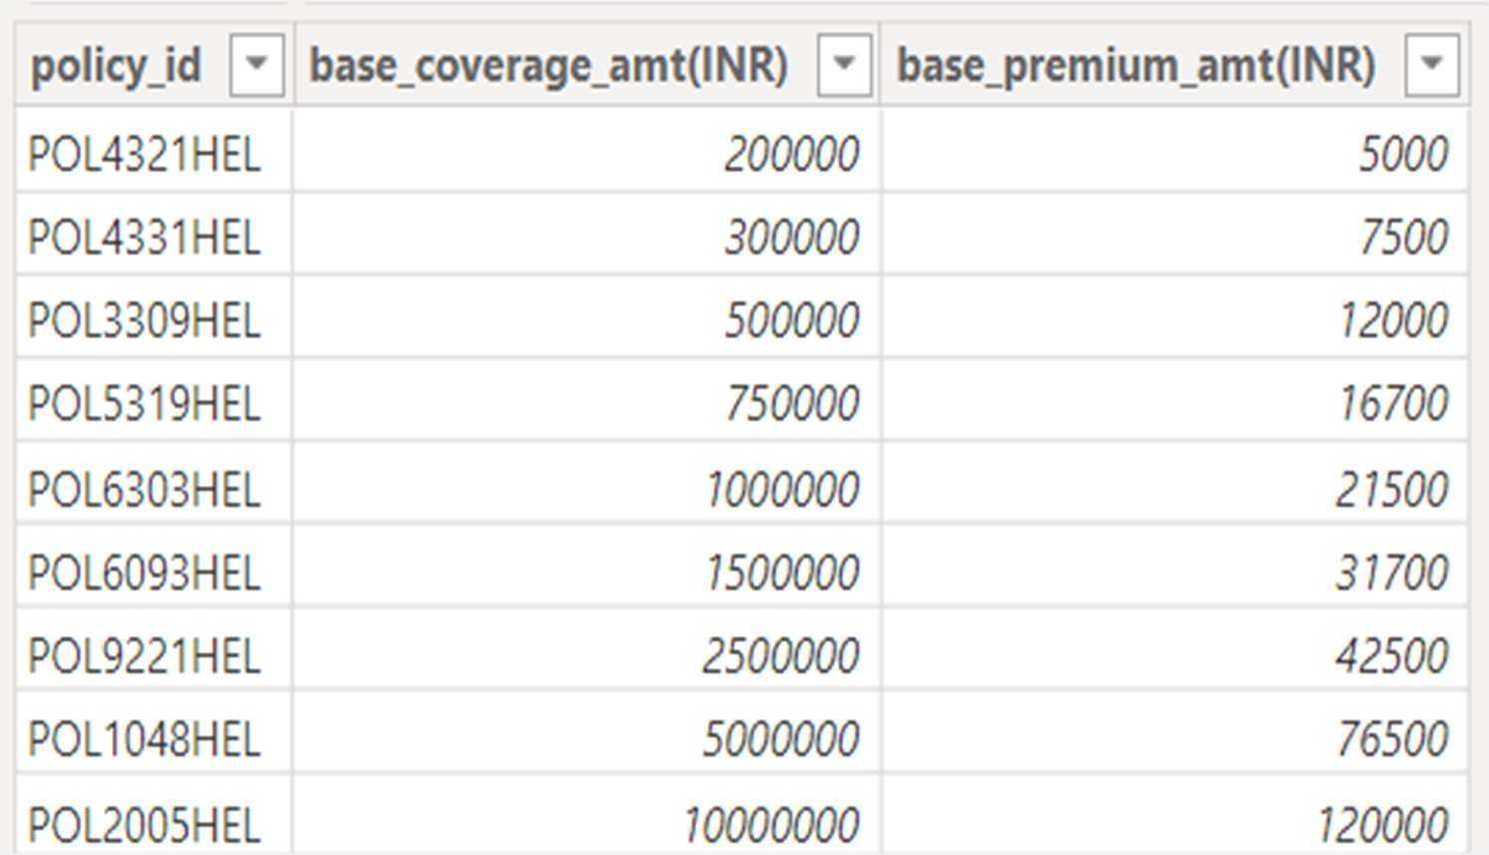
Shield Insurance provides a total of 9 policies


Sales Mode


Online
Offline



Online-Website
Offline-Agent



Online-App
Offline-Direct


Cities


Delhi NCR

Hyderabad



Indore
Chennai
Mumbai

Dataset
- Dim_customer
- Dim_policies
- Dim_date
- Fact_Premium
- Fact_Settlement

Data was available from nov 2022 till apr 2023












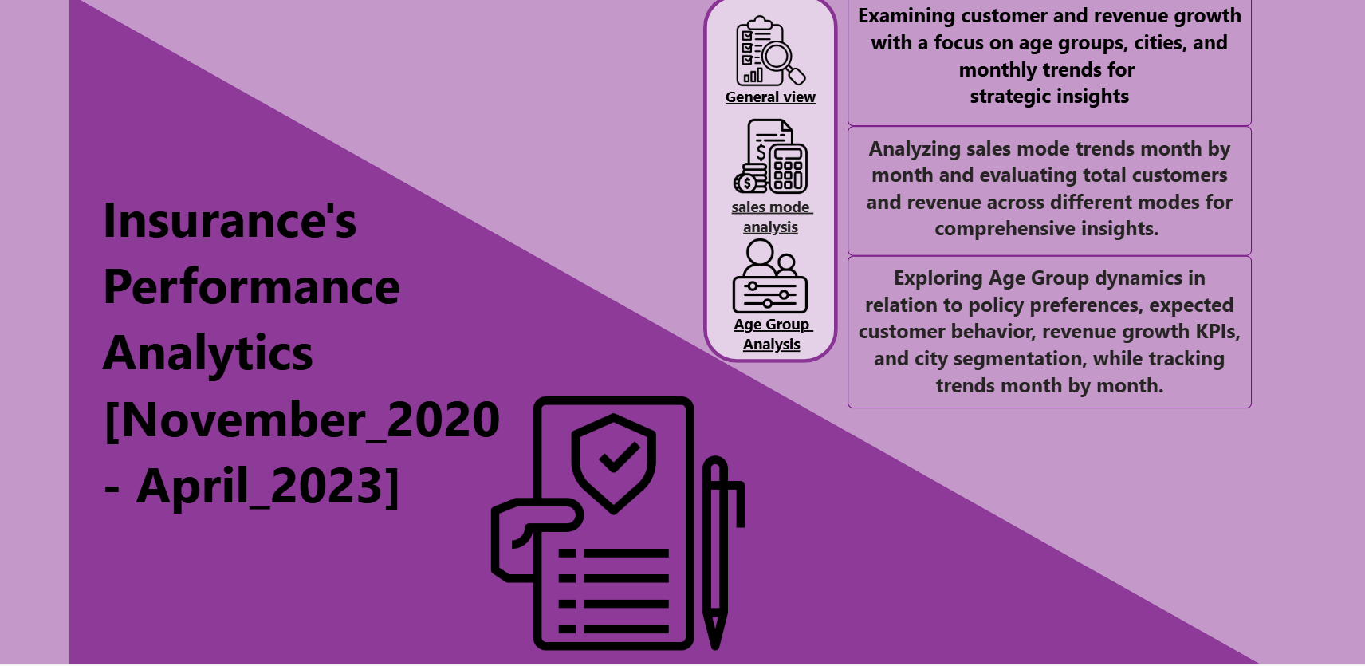

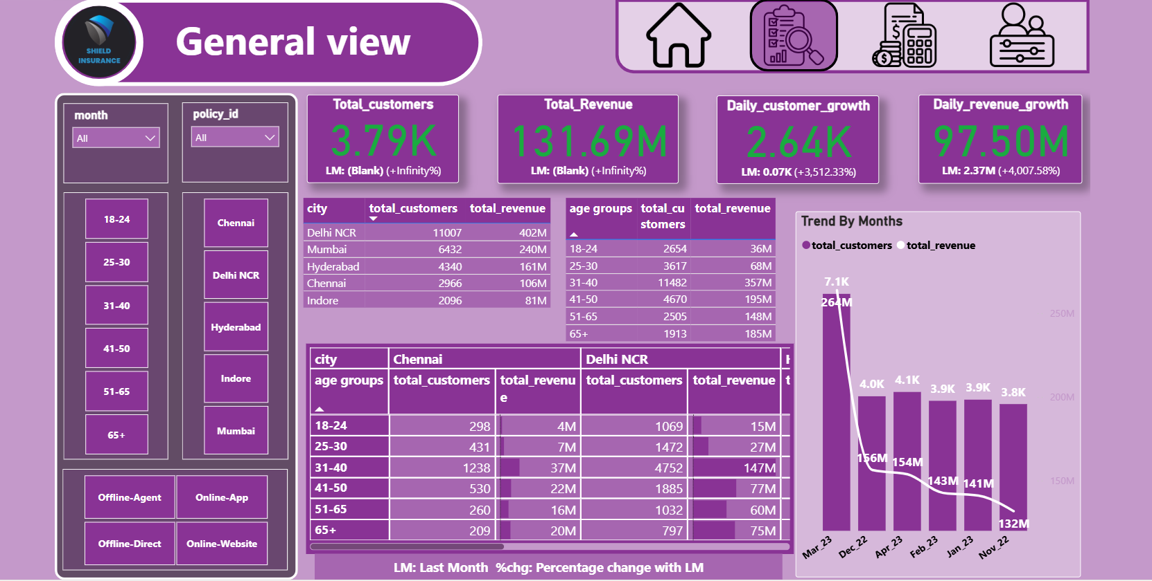

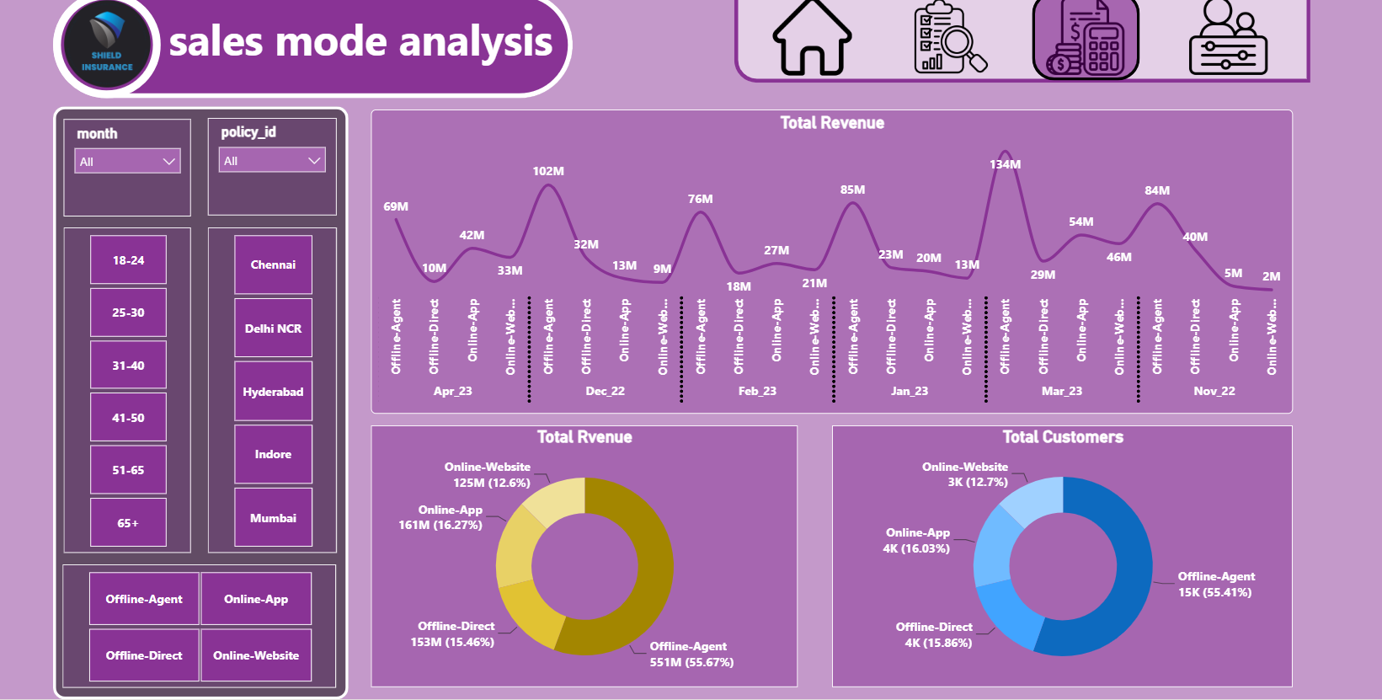

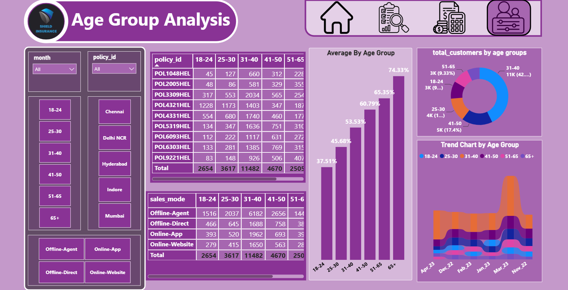


- March 2023 Performance Peak: Witnessed the highest revenue and customer acquisition.
- Delhi NCR Dominance: Led in revenue and customer acquisition among all cities.

- Key Age Group Contribution: The 31-40 age group significantly contributed to both revenue and customer base
- .
- Sales Mode Impact: Offline-Agent sales mode attracted the most customers and generated the highest revenue.

- Online Sales Dynamics: Online App and Website showed revenue growth from Feb 2023, while Offline-Direct declined.

- Popular Policy: Policy 'POL4321HEL' with a base premium of ₹5,000/- gathered a customer base exceeding 4000.

- Age Group Preference: The 31-40 age group appeared as the prominent customer base across all policies.

  - March Success Analysis: Investigate factors driving the exceptional performance in March for potential replicable strategies.

  - City-Wise Strategies: Leverage successful tactics from Delhi NCR to balance revenue growth across all cities.

  - Targeted Age Group Campaigns: Develop tailored marketing or policy offerings for the 31-40 age group to further capitalize on their significance.

  - Online Sales Enhancement: Revamp the Offline-Direct mode by leveraging insights from successful Online App and Website sales.

  - Policy Expansion: Explore variations of the popular 'POL4321HEL' policy to attract a wider customer base across different demographics.


Dhaval Patel Hemanand Vadivel



